WEEK-7 REACT APPLICATION

React-App 1 :

IndianPlayers :
import React from "react";

function IndianPlayers() {
// Odd and even team players using destructuring
const players = ["Rohit", "Virat", "Gill", "Ishan", "Hardik", "Jadeja"];
const [p1, p2, p3, p4, p5, p6] = players;

const oddTeam = [p1, p3, p5];
const evenTeam = [p2, p4, p6];

// Merging two arrays using spread operator
const T20players = ["Surya", "Rinku", "Samson"];
const RanjiTrophyPlayers = ["Rahane", "Pujara", "Umesh"];
const allPlayers = [...T20players, ...RanjiTrophyPlayers];

return (
<div>
<h2>Odd Team Players</h2>
<ul>
{oddTeam.map((player, index) => (
<li key={index}>{player}</li>
))}
</ul>

<h2>Even Team Players</h2>
<ul>
{evenTeam.map((player, index) => (
<li key={index}>{player}</li>
))}
</ul>

<h2>All Merged Players (T20 + Ranji)</h2>
<ul>
{allPlayers.map((player, index) => (
<li key={index}>{player}</li>
))}
</ul>
</div>
);
}

export default IndianPlayers;

ListOfPlayers :
import React from "react";

function ListOfPlayers() {
const players = [
{ name: "Rohit", score: 80 },
{ name: "Virat", score: 95 },
{ name: "Gill", score: 65 },
{ name: "Ishan", score: 45 },
{ name: "Hardik", score: 78 },
{ name: "Jadeja", score: 60 },
{ name: "Bumrah", score: 30 },
{ name: "Shami", score: 55 },
{ name: "Kuldeep", score: 40 },
{ name: "Siraj", score: 70 },
{ name: "Pant", score: 50 }
];

// Filter players with score < 70 using arrow function
const lowScorers = players.filter(p => p.score < 70);

return (
<div>
<h2>All Players</h2>
<ul>
{players.map((player, index) => (
<li key={index}>{player.name} - {player.score}</li>
))}
</ul>

<h2>Players with Score &lt; 70</h2>
<ul>
{lowScorers.map((player, index) => (
<li key={index}>{player.name} - {player.score}</li>
))}
</ul>
</div>
);
}

export default ListOfPlayers;

App.js :
import React from "react";
import ListOfPlayers from "./components/ListOfPlayers";
import IndianPlayers from "./components/IndianPlayers";

function App() {
const flag = true; // change to false to show IndianPlayers

return (
<div className="App">
<h1 style={{ color: "#00A36C" }}>🏏 Welcome to Cricket App</h1>
{flag ? <ListOfPlayers /> : <IndianPlayers />}
</div>
);
}

export default App;

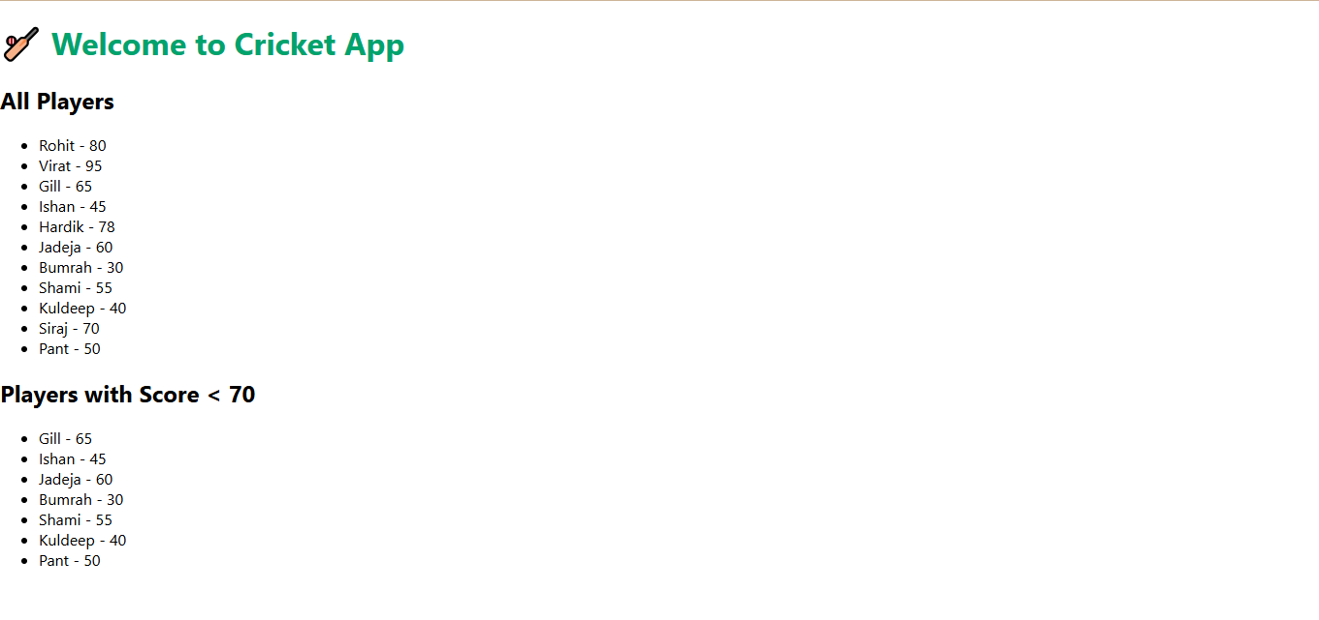

React-App 2 :

App.js :
import React from "react";

function App() {
// Object for a single office
const office = {
name: "GreenTech Tower",
rent: 55000,
address: "No.10, Anna Salai, Chennai",
image: "https://via.placeholder.com/300x200?text=Office+Space"
};

// List of offices
const officeList = [
{
name: "GreenTech Tower",
rent: 55000,
address: "No.10, Anna Salai, Chennai",
image: "https://via.placeholder.com/200x120?text=GreenTech"
},
{
name: "Skyline Plaza",
rent: 75000,
address: "Block B, Bangalore",
image: "https://via.placeholder.com/200x120?text=Skyline"
},
{
name: "EcoSpace",
rent: 40000,
address: "Sector 22, Hyderabad",
image: "https://via.placeholder.com/200x120?text=EcoSpace"
}
];

return (
<div>
{/* JSX Heading */}
<h1 style={{ textAlign: "center", color: "#00A36C" }}>
🏢 Office Space Rental App
</h1>

{/* React.createElement Example */}
{React.createElement("h2", null, "Single Office Details")}

{/* Display single office using JSX and object */}
<div
style={{
border: "1px solid gray",
padding: "10px",
margin: "10px",
borderRadius: "10px"
}}
>
<img src={office.image} alt={office.name} />
<h3>{office.name}</h3>
<p>Address: {office.address}</p>
<p style={{ color: office.rent < 60000 ? "red" : "green" }}>
Rent: ₹{office.rent}
</p>
</div>

{/* Display list of office items */}
<h2>All Available Offices</h2>
{officeList.map((item, index) => (
<div
key={index}
style={{
border: "1px solid #ccc",
marginBottom: "10px",
padding: "10px",
borderRadius: "10px"
}}
>
<img src={item.image} alt={item.name} />
<h3>{item.name}</h3>
<p>{item.address}</p>
<p style={{ color: item.rent < 60000 ? "red" : "green" }}>
Rent: ₹{item.rent}
</p>
</div>
))}
</div>
);
}

export default App;

index.css :
body {
margin: 0;
padding: 20px;
font-family: Arial, sans-serif;
background-color: #f0f0f0;
}

Index.js :
import React from 'react';
import ReactDOM from 'react-dom/client';
import App from './App';
import './index.css'; // Optional for global styles

const root = ReactDOM.createRoot(document.getElementById('root'));
root.render(<App />);

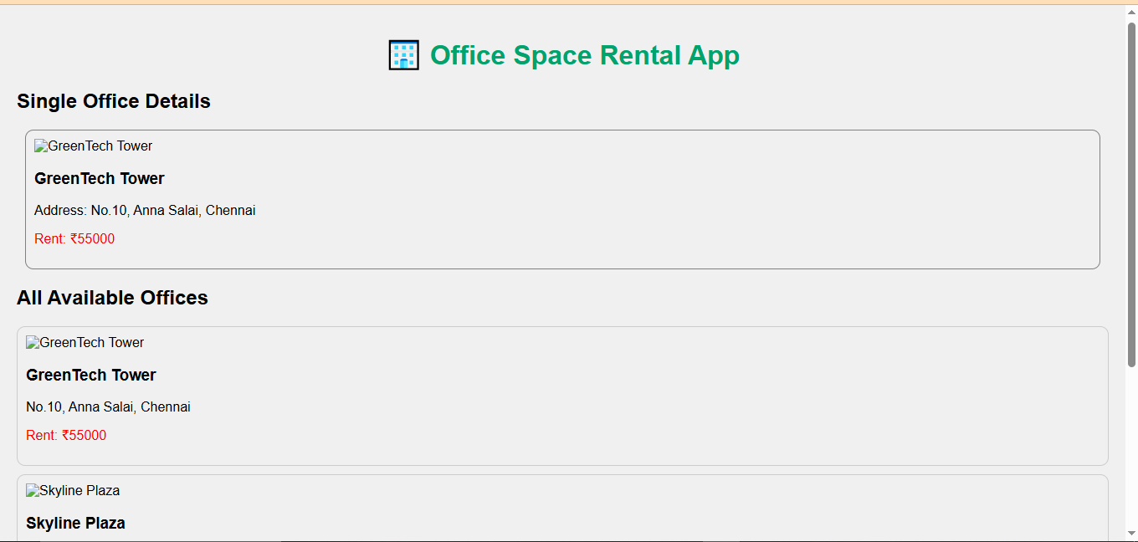

React-App 3 :

Counter.js :
import React, { Component } from 'react';

class Counter extends Component {
constructor() {
super();
this.state = {
count: 0
};
}

increment = () => {
this.setState({ count: this.state.count + 1 });
this.sayHello(); // invoking multiple methods
};

decrement = () => {
this.setState({ count: this.state.count - 1 });
};

sayHello = () => {
console.log("Hello! This is a static message.");
};

sayWelcome = (message) => {
alert("Message: " + message);
};

handleClick = (e) => {
alert("I was clicked!"); // Synthetic Event
console.log(e); // React Synthetic Event Object
};

render() {
return (
<div>
<h2>Counter Value: {this.state.count}</h2>
<button onClick={this.increment}>Increment</button>
<button onClick={this.decrement}>Decrement</button>
<button onClick={() => this.sayWelcome("Welcome!")}>Say Welcome</button>
<button onClick={this.handleClick}>Synthetic Event Button</button>
</div>
);
}
}

export default Counter;

CurrencyCovertor.js :

import React, { useState } from 'react';

function CurrencyConvertor() {
const [rupees, setRupees] = useState("");
const [euro, setEuro] = useState("");

const handleSubmit = () => {
const result = parseFloat(rupees) / 90;
setEuro(result.toFixed(2));
};

return (
<div>
<h2>Currency Converter (INR → EURO)</h2>
<input
type="text"
value={rupees}
onChange={(e) => setRupees(e.target.value)}
placeholder="Enter INR"
/>
<button onClick={handleSubmit}>Convert</button>
{euro && <p>Converted Euro: €{euro}</p>}
</div>
);
}

export default CurrencyConvertor;

App.css :
.App {
text-align: center;
padding: 20px;
}

button {
margin: 5px;
padding: 10px;
font-size: 16px;
}

App.js :
import React from 'react';
import Counter from './components/Counter';
import CurrencyConvertor from './components/CurrencyConvertor';

function App() {
return (
<div className="App">
<h1>🎯 React Event Handling Examples</h1>
<Counter />
<hr />
<CurrencyConvertor />
</div>
);
}

export default App;

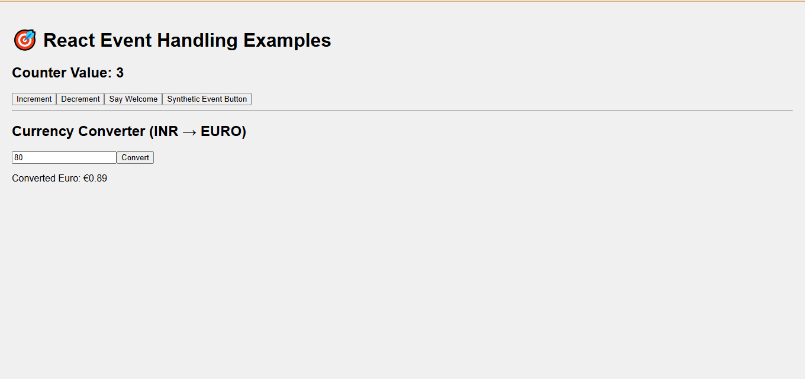

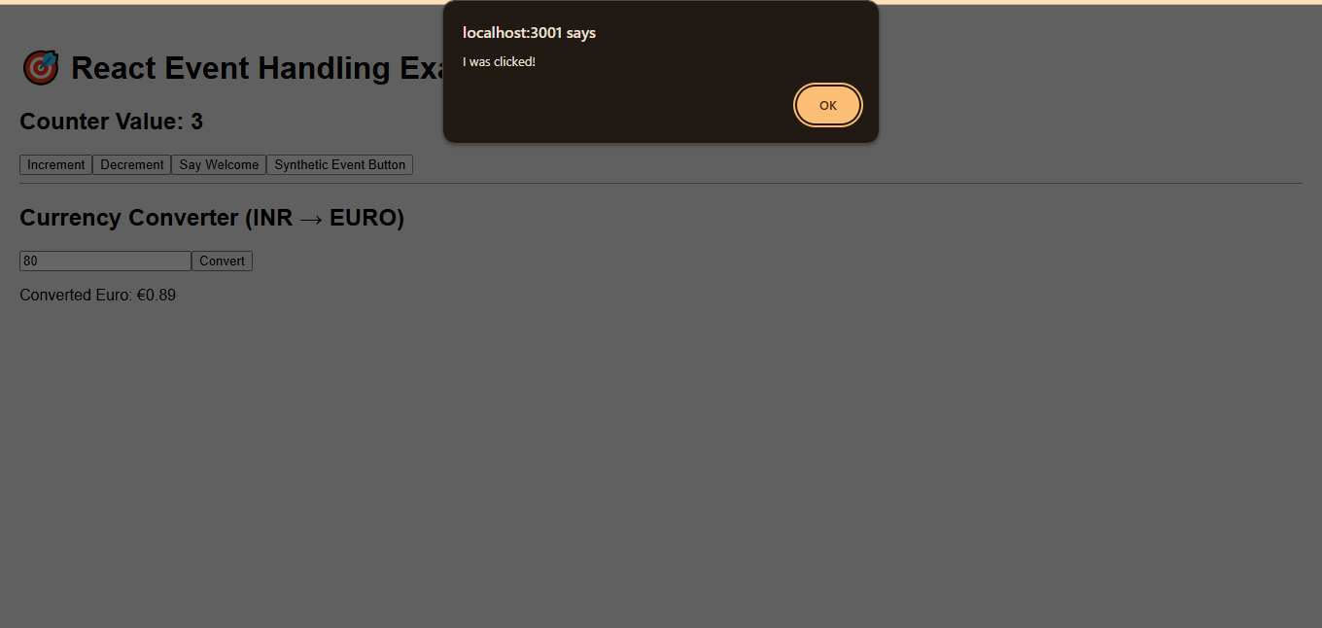

React-App 4 :

GuestPage.js :

// src/components/GuestPage.js
import React from 'react';

function GuestPage({ onLogin }) {
return (
<div>
<h2>Welcome, Guest!</h2>
<p>🛫 Flight Details: Chennai ✈ Delhi — ₹5,000</p>
<button onClick={onLogin}>Login to Book</button>
</div>
);
}

export default GuestPage;

UserPage.js :

// src/components/UserPage.js
import React from 'react';

function UserPage({ onLogout }) {
return (
<div>
<h2>Welcome, User!</h2>
<p>🛫 Book your ticket: Chennai ✈ Delhi — ₹5,000</p>
<button>Book Now</button>
<br /><br />
<button onClick={onLogout}>Logout</button>
</div>
);
}

export default UserPage;

App.css :

.App {
text-align: center;
padding: 2rem;
font-family: sans-serif;
}

button {
padding: 10px 20px;
font-size: 16px;
margin: 10px;
}

App.js :

// src/App.js
import React, { useState } from 'react';
import GuestPage from './components/GuestPage';
import UserPage from './components/UserPage';

function App() {
const [isLoggedIn, setIsLoggedIn] = useState(false);

// Define login/logout handlers
const handleLogin = () => setIsLoggedIn(true);
const handleLogout = () => setIsLoggedIn(false);

// Element variable for conditional rendering
let content;
if (isLoggedIn) {
content = <UserPage onLogout={handleLogout} />;
} else {
content = <GuestPage onLogin={handleLogin} />;
}

return (
<div className="App">
<h1>✈️ Ticket Booking App</h1>
{content}
</div>
);
}

export default App;

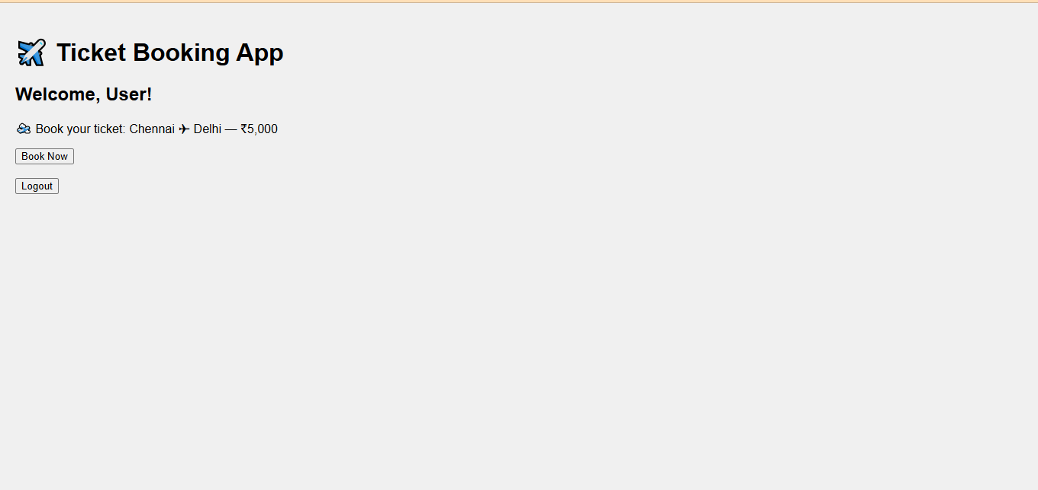

React-App 5 :

BlogDetails.js :

// src/components/BlogDetails.js
import React from 'react';

const blogs = [
{ id: 1, title: 'React Hooks Deep Dive' },
{ id: 2, title: 'Advanced JavaScript Concepts' },
];

function BlogDetails() {
return (
<div>
<h2>📝 Blog Details</h2>
<ul>
{blogs.map((blog) => (
<li key={blog.id}>{blog.title}</li>
))}
</ul>
</div>
);
}

export default BlogDetails;

BookDetails.js :
// src/components/BookDetails.js
import React from 'react';

const books = [
{ id: 1, title: 'Learn React', author: 'Dan Abramov' },
{ id: 2, title: 'JavaScript Mastery', author: 'Kyle Simpson' },
];

function BookDetails() {
return (
<div>
<h2>📚 Book Details</h2>
<ul>
{books.map((book) => (
<li key={book.id}>
<b>{book.title}</b> - {book.author}
</li>
))}
</ul>
</div>
);
}

export default BookDetails;

App.js :
// src/App.js
import React, { useState } from 'react';
import BookDetails from './components/BookDetails';
import BlogDetails from './components/BlogDetails';
import CourseDetails from './components/CourseDetails';

function App() {
const [view, setView] = useState('book');

// Element variable example
let content;
if (view === 'book') content = <BookDetails />;
else if (view === 'blog') content = <BlogDetails />;
else content = <CourseDetails />;

return (
<div className="App">
<h1>📘 Blogger App</h1>

{/* Buttons to switch */}
<div>
<button onClick={() => setView('book')}>Books</button>
<button onClick={() => setView('blog')}>Blogs</button>
<button onClick={() => setView('course')}>Courses</button>
</div>

<hr />

{/* Method 1: Element Variable */}
{content}

{/* Method 2: Ternary Operator */}
{/* {view === 'book' ? <BookDetails /> : view === 'blog' ? <BlogDetails /> : <CourseDetails />} */}

{/* Method 3: Logical AND */}
{/* {view === 'book' && <BookDetails />}
{view === 'blog' && <BlogDetails />}
{view === 'course' && <CourseDetails />} */}
</div>
);
}

export default App;

